Journal #8
What global issue is being communicated? *Utilize handout to assist.
What is the visual communicating about the global issue?
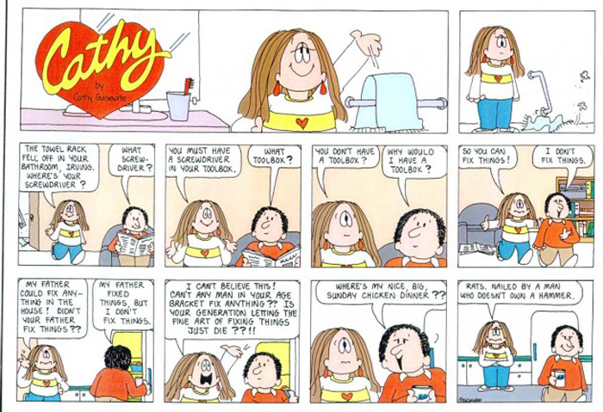
How does the following visual communicate a global issue?

