“The Convergence of the Twain” (Lines on the Loss of the “Titanic”)
Thomas Hardy, 1912
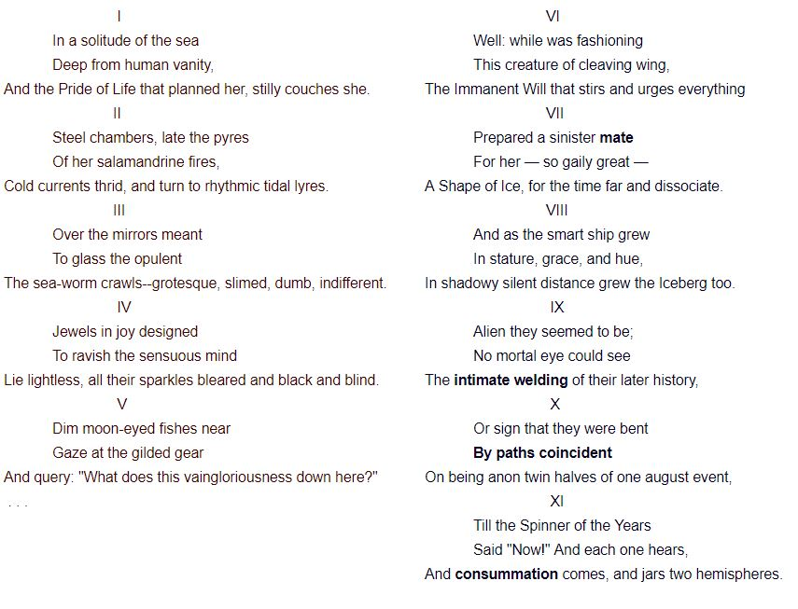
Poetry is a rhythmic representation of diction, imagery, symbol, syntax, and other literary elements. In creating music, poets may use end rhyme, alliteration, assonance, consonance, anaphora, refrain, and/or some other sound-related techniques. So, you would want to slow down a bit, so that you can catch the musical elements in this poem.
Why don't you practice this routine, when you encounter a new poem, look around--listen--mull it over--and tell?
​Look around: where is the ship, Titanic, at the beginning of the poem? The title and subtitle will help guide you. The Titanic is lost. Stanzas 1 and 4 provide more clues: the ship is far away from human society, "deep" "in a solitude of the sea," lying "lightless." Stanzas 2-4 depict the lofty pride and lavish lifestyle of the affluent that are now reduced into the lifeless testament of human vanity and blindness.
In Stanza 5, we might as well join the fishes in gawking at the sunken ship.
On a different note, why do you think Hardy uses capitalization so frequently?
Listen: what music and tone does the poem create? Each three lines--what we call a triplet--form a stanza and the same end rhyme intensifies the unity among these lines. Alliteration and consonance are heavily utilized to enhance the bleak and ominous tone: "lie lightless, all their sparkles bleared and black and blind."
Mull it over: what is the speaker's attitude toward the sinking of this ship? Poets deliberately choose descriptive words, what we call diction, to conjure up specific images in the reader. What imagery do "twain," "mate," "intimate," "welding," "path coincidental," and "consummation" evoke in you? What force do you think would prepare such a fateful, ominous union between the Ship and the Iceberg? Is it closer to God or to Nature in your view?
And now tell us what this poem is about.

