“In a Station of the Metro” (Ezra Pound, 1913)

The apparition of these faces in the crowd:
Petals on a wet, black bough.
These two lines--which are the whole extent of this poem--are the best-known example of imagist poetry.
Following is an introduction to imagism as appeared on
www.poets.org/poetsorg/text/brief-guide-imagism:
Imagism was a reaction against the flabby abstract language and “careless thinking” of Georgian romanticism. Imagist poetry aimed to replace muddy abstractions with exactness of observed detail, apt metaphors, and economy of language. For example, Pound’s “In a Station of the Metro” started from a glimpse of beautiful faces in a dark subway and elevated that perception into a crisp vision by finding an intensified equivalent image. The metaphor provokes a sharp, intuitive discovery in order to get at the essence of life.
Pound’s definition of the image was “that which presents an intellectual and emotional complex in an instant of time.” Pound defined the tenets of imagist poetry as:
I. Direct treatment of the “thing," whether subjective or objective.
II. To use absolutely no word that does not contribute to the presentation.
III. As regarding rhythm: to compose in sequence of the musical phrase, not in sequence of the metronome.

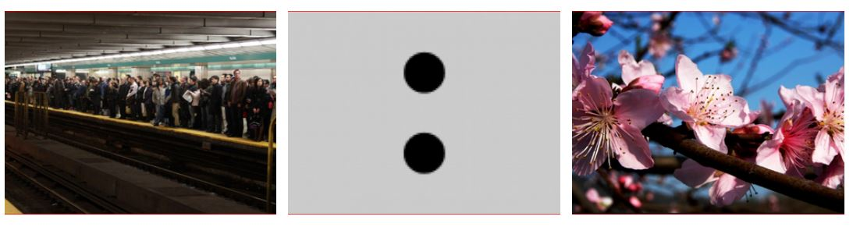
These pictures above (from left to right) visualize how the juxtaposition transforms into a contrast from line 1 to line 2. As you can see, the contrast before and after the colon is very striking and stunning. Consider what literary or syntactic devices Pound employs to achieve such luminous imagery.

